



NSRL-3 RUN

FINAL REPORT

Marcelo E. Vazquez

Medical Department
NASA-BNL Liaison Scientist
BNL/NASA webpage:
http://www.bnl.gov/medical/NASA/NASA-home%20frame.htm

JUNE 2004

TABLE OF CONTENTS

Executive Summary 3

NSRL-3 Proposals/SACR Review 4

Participants 5

Participants Statistics 7

Participants Institutions 8

NSRL-3 1 GeV/n Proton Run Description 10

NSRL-3 1 GeV/n Iron Run Description 11

NSRL-3 0.6 GeV/n Iron Run Description 12

NSRL-3 1 GeV/n Iron-Proton Run Description 13

NSRL- 3 Final Run Description 14

Descriptive Statistics 15

Beam Characteristics 19

Experimenters and Run Statistics 20

Participants, Experimental Samples and Endpoints 21

List of Personnel 23

EXECUTIVE SUMMARY
During the summer of 2004, a series of radiobiological and physics experiments were performed using the NASA Space Radiation Laboratory to accelerate iron and proton beams (NSRL-3). These experiments were part of the third NSRL scientific run sponsored by NASA’s Space Radiation Health Program (SRHP) heavy ion radiobiology research program at BNL.

A total of 24 proposals were approved by the BNL’ SACR to participate in the NSRL-3 run. Twenty institutions from the United States and 2 from foreign countries (Japan and Italy) were represented, totaling 78 users. More than 800 biological samples were exposed at the NSRL beam line, employing 286 hours of beam time (40 hours for in vivo studies, 74.5 hours for in vitro studies and 66 hours for physics experiments). In addition, 6 hours were used for beam development and, 93.5 hours for set-up and dosimetry. A total of 6.5 hours of beam time were lost due to accelerator related problems.

During NSRL-3, Booster provided iron (0.577 and 0.969 GeV/nucleon, LET: 176.1 and 151.1 keV/µm) and Protons (1 GeV/n, LET: 0.021 keV/µm) beams for biology and physics experiments. The dose/rates used were as low as 0.1 cGy/min and as high as 2000 cGy/min. The spill rate employed was 20 for Fe, with duration of 400 msec/spill. The spill fluence was (particles/spill) 3 x 10⁹ (max) and 500 (min). Square beam spots as big as 20 x 20 cm and small as 1 x 1 cm was employed for biology and physics experiments. For the first time Tandem-Booster-NSRL complex was able to deliver a mix field composed by iron and protons with energies of 1 GeV/n with a steady and repeatable switching from protons to iron. The longest switching time was 7 minutes and the shortest was 1 minute. The typical one was ~2 minutes. This new capability will offer more realistic sample exposures using cells and animals eventually.

Tandem-Booster set-up started on June 6 with the transport and circulation of p beams at the NSRL complex. Beam was tuned into cave on June 7. 1000 MeV/n p beams were available for tuning on June 7. The next several shifts were spent on beam characterization and dosimetry in preparation of biological and physics experiments. Biology studies started on the morning of June 8 using p beams (Cucinotta-Wu, NASA) and proceeded through June 10. On June 11, AGS-Booster tuned 1 GeV/n iron beams for biology and physics studies ending on June 23. From June 24 to late June 26, NSRL delivered 0.6 GeV/n iron beams for a limited series of biological experiments. On the early morning of June 28, Tandem-Booster complex delivered iron ions and protons 1 GeV/n to test fast delivery of mixed ions for physics and biology. A series of biological experiments using mixed field were completed on the evening of June 30 (B. Sutherland). NSRL-3 officially ended at 1900 pm, June 30, 2004.

One of the NSRL-4 highlights, was the commencement of the new NASA sponsored Space Radiation Summer School on June 1, 2004. The school made use of the NSRL facilities to train 11 students selected by NASA, in the basic concepts of high-LET radiobiology and how to plan and execute an experiment using NSRL. The students and faculty employed 13 hour of beam time to expose cell, animals and detectors to iron ions.

NSRL-3 Projects Reviewed by the BNL’s Scientific Advisory Committee in Radiobiology (SACR):

Proposal | PI | Funding | NSRL-3 Participation
B3 | Cucinotta | NASA | Yes
B7 | Rabin | NASA | Yes
B65 | Vazquez | NSBRI | Yes
B66 | Narici | ISA | Yes
B73 | Sutherland | DOE/NASA | Yes
N88 | Sutherland | NASA | Yes
N89 | Held | NASA | Yes
N91 | Rydberg | NASA | Yes
N95 | Story | NASA | Yes
N99 | Zhao | NASA | Yes
N103 | Barcellos-Hoff | NASA | Yes
N104 | Weil/Ullrich | NASA | Yes
N105 | Chatterjee | NASA | No
N108 | Pecaut | NASA | Yes
N113 | Pecaut | NASA | Yes
N115 | Bacher | NASA | No
N118 | Miller | NASA | Yes
N119 | Archambeau | NASA | No
N121 | Moyer | NASA | Yes
N122 | Nelson | NASA | Yes
N123 | Radeka | NSBRI | Yes
N124 | Li | NASA | Yes
N126 | Kennedy | NSBRI | Yes
N128 | Vazquez | NASA | Yes

NSRL-3 PARTICIPANTS

Exp. | Participants | Affiliation | Title
B-3 | F. Cucinotta*  K. George  H. Wu  N. Desai | NASA, Johnson Space Center, TX  “  “  “ | Ph.D, Principal Investigator  Senior Research Associate  Ph.D., Co-Worker  B.S., Co-Worker
B-7 | B. Rabin  A. Carey  K. Carhill | UMBC, Baltimore, MD  “  “ | Ph.D, Principal Investigator  B.A., Co-worker  B.A., Co-worker
B-52 | A. Gewirtz*  B. Sutherland  P. Bennett  M. Naidu  D. Roy  M. Hada  J. Sutherland  D. Monteleone  J. Trunk | University of Penn. School of Medicine, PA  BNL, Biology Dept., Upton, NY  “  “  “  “  “  “  “ | Ph.D, Principal Investigator  Ph.D, Co-Principal Invest.  M.S., Co-Worker  Ph.D., Co-Worker  Ph.D., Co-Worker  Ph.D., Co-Worker  Ph.D., Co-Worker  B.S., Co-Worker  B.S., Co-Worker
B-65 | M. Vazquez  P. Guida  - Billups  K. Nojima | Brookhaven National Laboratory, NY  “  “  NIRS/HIMAC, Japan | M.D, Ph.D, Principal Invest.  Ph.D, Co-Worker  B.S., Co-Worker  Ph.D, Co-Worker
B-66 | L. Narici  V. Bidoli  F. Belli  S. Carozzo | University of Rome 'Tor Vergata'  “  “  “ | Ph.D, Principal Investigator  Ph.D., Co-Worker  Ph.D., Co-Worker  Ph.D., Co-Worker
B-73  N-88 | B. Sutherland  P. Bennett  M. Naidu  D. Roy  M. Hada  P. Kumar  J. Sutherland  D. Monteleone  J. Trunk | Brookhaven National Laboratory, NY  “  “  “  “  “  “  “  “ | Ph.D, Principal Investigator  M.S., Co-Worker  Ph.D., Co-Worker  Ph.D., Co-Worker  Ph.D., Co-Worker  Ph.D., Co-Worker  Ph.D., Co-Worker  B.S., Co-Worker  B.S., Co-Worker
N-89 | K. Held  H. Yang  V. Anzenberg | Massachusetts General Hospital/ Harvard Medical School  “ | Ph.D, Principal Investigator  Ph.D., Co-worker  B.S., Co-worker
N-91 | B. Rydberg | LBNL, Berkeley, CA | Ph.D, Principal Investigator
N-95 | M. Story  U. Giri | University of Texas, MD Anderson, TX  “ | Ph.D, Principal Investigator  Ph.D., Co-worker
N-99 | Y. Zhao  C. Piao | Columbia University, NY  “ | Ph.D., Principal Investigator  Ph.D., Co-worker
N-103 | M. Barcellos-Hoff*  B. Rydberg  S. Costas  L. Ding | LBNL, Berkeley, CA  “  “  “ | Ph.D., Principal Investigator  Ph.D., Co-worker  Ph.D., Co-worker  Ph.D., Co-worker
N-104 | M. Weil  R. Ullrich  F. Ray  P. Genik  M. Callan | Colorado State University, CO  “  “  “  “ | Ph.D, Principal Investigator  Ph.D., Co-Principal Invest.  Ph.D., Co-worker  Ph.D., Co-worker  B.S., Co-worker
Exp. | Participants | Affiliation | Title
N-108  N-113 | M. Pecaut  A. Smith  A. Mosley | Loma Linda University, CA  “  “ | Ph.D, Principal Investigator  B.S, Co-Worker  B.S, Co-Worker
N-118 | J. Miller  C. Zeitlin  L. Heilbroin  M. Kristal | LBNL, Berkeley, CA  “  “  NASA Langley Research Center, VA | Ph.D, Principal Investigator  Ph.D., Co-Worker  Ph.D., Co-Worker  Ph.D., Co-Worker
N121 | M. Moyer  S. Rigthmar | Loma Linda University, CA  “ | Ph.D, Principal Investigator  B.S, Co-Worker
N-122 | G. Nelson  T. Jones  A. Smith  S. Rightnar  C. Perez | Loma Linda University, CA  “  “  “  “ | Ph.D, Principal Investigator  B.S., Co-Worker  B.S., Co-Worker  B.S., Co-Worker  B.S., Co-Worker
N-123 | V. Radeka  B. Yu  J. Mead | Brookhaven National Laboratory, NY  “  “ | Ph.D, Principal Investigator  Ph.D., Co-Worker  Ph.D., Co-Worker
N-124 | C-H. Li  Bin Yan  Qi Chen  Shanling Liu | Duke University, NC  “  “  “ | Ph.D, Principal Investigator  Ph.D., Co-Worker  Ph.D., Co-Worker  Ph.D., Co-Worker
N-126 | A. Kennedy  J. Ware  X. Wan  J. Guan  Z. Zhou  J. Stewart  J. Donahue | University of Pennsylvania, PA  “  “  “  “  “  “ | Sc.D, Principal Investigator  Ph.D., Co-Worker  Ph.D., Co-Worker  Ph.D., Co-Worker  M.S., Co-Worker  M.S., Co-Worker  M.S., Co-Worker
N-128 | M. Vazquez  G. Nelson  A. Kronenberg  A. Rusek  P. Guida  O. Rice  R. Vlkolinski  R. Sun  B. McKnight  L. Rein  C. Burrell  P. Pandya  V. Serra  E. Lloyd  L. Thomas  V. Anzenberg  T. Jones  A. Smith | Brookhaven National Laboratory, NY  Loma Linda University, CA  LBNL, Berkeley, CA  Brookhaven National Laboratory, NY  “  “  Scripps Research Institute / NSCOR, CA  Washington University / NSCOR, WA  North Carolina A&T, NC  Johnson Space Center, TX  Loma Linda University, CA  “  “  “  Southampton College, NY  MIT / Mass General Hospital, MA  Loma Linda University, CA  “ | Ph.D, Principal Investigator  Ph.D., Co-Worker  Ph.D., Co-Worker  Ph.D., Co-Worker  Ph.D., Co-Worker  Ph.D., Co-Worker  Ph.D., Co-Worker  Ph.D., Co-Worker  Ph.D., Co-Worker  Research Associate  Grad Student  Grad Student  Grad Student  Research Assistant  Grad Student  Grad Student  B.S., Co-Worker  B.S., Co-Worker
*Not Present During Actual Run

NSRL-3 PARTICIPANTS STATISTICS

PARTICIPANTS | NSRL-3
Ph.D., Principal Investigators | 16
M.D., Ph.D., Principal Investigators | 1
Ph.D., Co-Principal Investigators | 1
Sc.D., Principal Investigators | 1
Co-Workers  Ph.D.  Graduate Students  M.S.  B.S.  B.A.  Research Assistant  Research Associate  Senior Research Associate | 35  5  4  10  2  1  1  1
Total: | 78

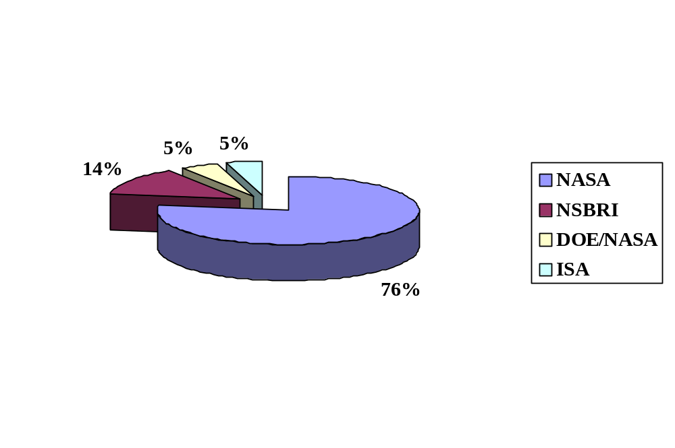RESEARCH PROJECT SPONSORS:

Participant Institutions

NASA related centers/institutes (4)
- NASA, Johnson Space Center, TX
- National Space Biomedical Research Institute, TX
- NASA Langley Research Center, VA
- NASA NSCORTs

National Laboratories/Institutes (2)
- Brookhaven National Laboratory, NY
- Lawrence Berkeley National Laboratory, CA

Universities (14)
- UMBC, Baltimore, MD
- University of Penn. School of Medicine, PA
- Massachusetts General Hospital/ Harvard Medical School, MA
- University of Texas, MD Anderson, TX
- Columbia University, NY
- Colorado State University, CO
- Loma Linda University, CA
- Duke University, NC
- University of Pennsylvania, PA
- North Carolina A&T, NC
- Southampton College, NY
- MIT / Mass General Hospital, MA
- Scripps Research Institute / NSCOR, CA
- Washington University / NSCOR, WA

Foreign Institutions (2)
- NIRS/HIMAC, Japan
- University of Rome 'Tor Vergata'

INSTITUTIONS STATISTICS:
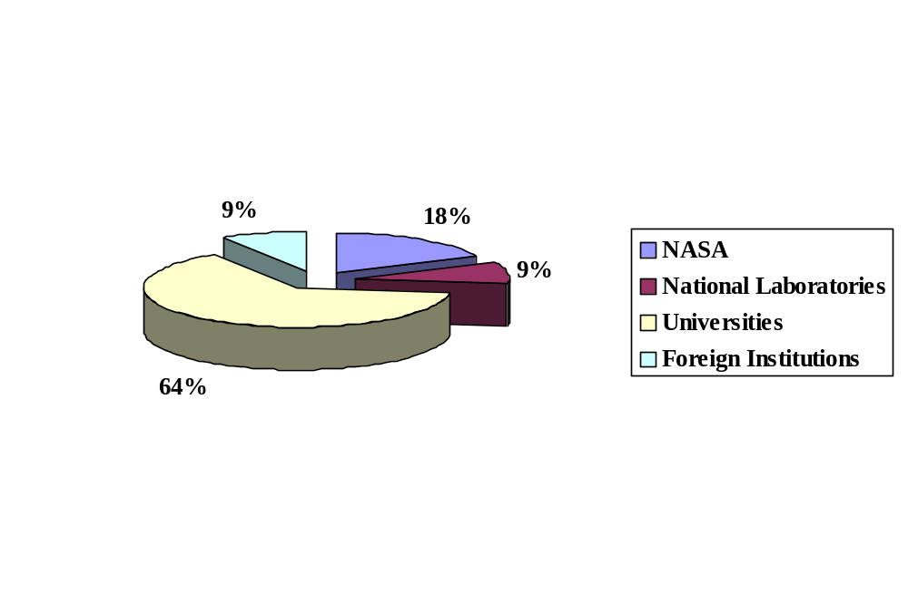

U.S. Participant Institutions and State Distribution
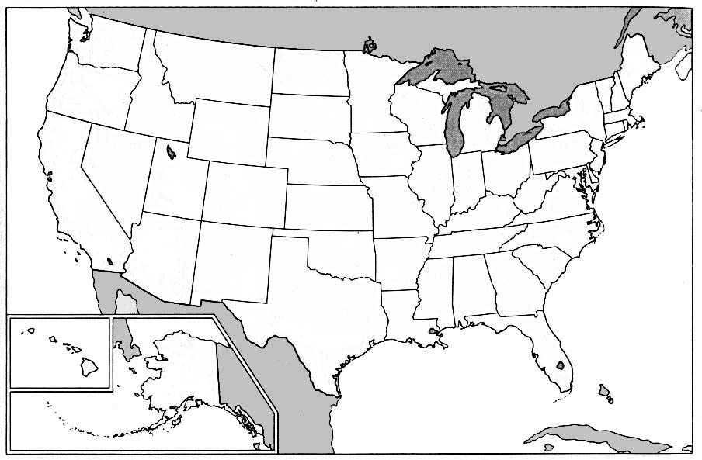
NASA Related Centers
National Laboratories
Universities
Privates Institutions

California
- Lawrence Berkeley National Laboratory, Berkeley
- Loma Linda University, Loma Linda
- Scripps Research Institute / NSCOR, CA
Colorado
- Colorado State University, Fort Collins
Maryland
- UMBC, Baltimore
Massachusetts
- Massachusetts General Hospital/ Harvard Medical School
- MIT / Mass General Hospital, MA
New York
- Brookhaven National Laboratory, Upton
- Columbia University, New York
- Southampton College, Southhampton
North Carolina
- North Carolina A&T,
- Duke University, NC
Pennsylvania
- University of Pennsylvania School of Medicine, Philadelphia
- University of Pennsylvania, Philadelphia
Texas
- NASA Johnson Space Center, Houston
- National Space Biomedical Research Institute, Houston
- University of Texas MD Anderson
Virginia
- NASA Langley Research Center
Washington
Washington University / NSCOR
NSRL-3 PROTON 1 GeV/n RUN DESCRIPTION

RUN DATES
Run dates | Scheduled |  | Actual
 | Date | Time | Date | Time
Run start | 06/07 | 0700 | 06/07 | 0700
Run end | 06/10 | 2330 | 06/10 | 1930
Tuned into cave | 06/06 | 1700 | 06/06 | TBD
Beam delivered for Biology
p 1 GeV/n | 06/08 | 0900 | 06/08 | 0930
End run | 06/10 | 1830 | 06/10 | 1930

Beam Time Description (hours)

Total Clock Time | (from 06/07 0700 to 06/10 1930) |  | 64
Total Beam-on time |  |  | 60.5
Total Beam-off time |  |  | 3.5
Beam Time for Biology
p 1 GeV/n In Vitro Studies | 27.0
p 1 GeV/n In Vivo Studies | 2.5
Sub-total |  | 29.5
Beam Time for Physics | 8
Sub-total |  | 8
Set Up Time/Spill Structure | 20.0
Sub-total |  | 20.0
Set Up Time for Beam Develop. | 0
Sub-total |  | 0
MCR Wrap-Up Time | 3.0
Total |  | 3.0
Totals |  |  | 60.5
Contingency T. Planned | 4
Contingency T. Used | 2

NSRL-3 IRON 1 GeV/n RUN DESCRIPTION

RUN DATES
Run dates | Scheduled |  | Actual
 | Date | Time | Date | Time
Run start | 06/11 | 0700 | 06/11 | 0700
Run end | 06/23 | 2030 | 06/23 | 1600
Tuned into cave | 06/11 | 0700 | 06/11 | 1148
Beam delivered for Biology
Fe 1 GeV/n | 06/11 | 1300 | 06/11 | 1400
End run | 06/23 | 2030 | 06/23 | 1600

Beam Time Description (hours)

Total Clock Time | (from 06/11 0700 to 06/23 1600) |  | 146.5
Total Beam-on time |  |  | 143.5
Total Beam-off time |  |  | 3.0
Beam Time for Biology
Fe 1 GeV/n In Vitro Studies | 28.0
Fe 1 GeV/n In Vivo Studies | 18.0
Sub-total |  | 46.0
Beam Time for Physics | 58.0
Sub-total |  | 58.0
Set Up Time/Spill Structure | 27.0
Sub-total |  | 27.0
Set Up Time for Beam Develop. | 6.0
Sub-total |  | 6.0
MCR Wrap-Up Time | 6.5
Total |  | 6.5
Totals |  |  | 143.5
Contingency T. Planned | 11.0
Contingency T. Used | 7.5

NSRL-3 IRON 0.6 GeV/n RUN DESCRIPTION

RUN DATES
Run dates | Scheduled |  | Actual
 | Date | Time | Date | Time
Run start | 06/24 | 0700 | 06/24 | 0700
Run end | 06/27 | 0200 | 06/26 | 1830
Tuned into cave | 06/24 | 0600 | TBD | TBD
Beam delivered for Biology
Fe 0.6 GeV/n | 06/24 | 1100 | 06/24 | 1230
End run | 06/27 | 0200 | 06/26 | 1830

Beam Time Description (hours)

Total Clock Time | (from 06/24 0700 to 06/26 1830) |  | 34.5
Total Beam-on time |  |  | 34.5
Total Beam-off time |  |  | 0.0
Beam Time for Biology
Fe 0.6 GeV/n In Vitro Studies | 4.0
Fe 0.6 GeV/n In Vivo Studies | 19.5
Sub-total |  | 23.5
Beam Time for Physics | 0.0
Sub-total |  | 0.0
Time for Beam Develop. | 0.0
Sub-total |  | 0.0
Set Up Time/Spill Structure | 9.5
Sub-total |  | 9.5
MCR Wrap-Up Time | 1.5
Total |  | 1.5
Totals |  |  | 34.5
Contingency T. Planned | 3.0
Contingency T. Used | 0.0

NSRL-3 PROTON-IRON 1 GeV/n RUN DESCRIPTION

RUN DATES
Run dates | Scheduled |  | Actual
 | Date | Time | Date | Time
Run start | 06/29 | 0700 | 06/29 | 0700
Run end | 06/30 | 1700 | 06/30 | 1900
Tuned into cave | 06/28 | TBD | 06/28 | 1800
Beam delivered for Biology
Fe 0.6 GeV/n | 06/29 | 0900 | 06/29 | 1200
End run | 06/30 | 1600 | 06/30 | 1900

Beam Time Description (hours)

Total Clock Time | (from 06/23 0700 to 06/30 1900) |  | 41.0
Total Beam-on time |  |  | 41.0
Total Beam-off time |  |  | 0.0
Beam Time for Biology
In Vitro Studies | 15.5
In Vivo Studies | 0.0
Sub-total |  | 15.5
Beam Time for Physics | 0.0
Sub-total |  | 0.0
Time for Beam Develop. | 0.0
Sub-total |  | 0.0
Set Up Time/Spill Structure | 24.5
Sub-total |  | 24.5
MCR Wrap-Up Time | 1.0
Total |  | 1.0
Totals |  |  | 41.0
Contingency T. Planned | 3.0
Contingency T. Used | 3.0

NSRL-3 FINAL RUN DATES
Run dates | Scheduled |  | Actual
 | Date | Time | Date | Time
Run start | 06/07 | 0700 | 06/07 | 0700
Run end | 06/30 | 1700 | 06/30 | 1900
Tuned into cave | 06/06 | 1700 | 06/06 | TBD

total Beam Time Description (hours)

Planned Total Clock Time | (from 06/07 0700 to 06/30 1700) |  | 309
Actual Total Clock Time | (from 06/07 0700 to 06/26 1900) |  | 286
Total Beam-on Time
p 1 GeV/n | 60.5
Fe 1 GeV/n | 144.0
Fe 0.6 GeV/n | 34.5
P + Fe 1 GeV/n | 41.0
Total |  | 280.0
Total Beam-off time
p 1 GeV/n | 3.5
Fe 1 GeV/n | 3.0
Fe 0.6 GeV/n | 0.0
P + Fe 1 GeV/n | 0.0
Total |  | 6.5
Total Beam Time for Biology
In Vivo Studies | 40.0
In Vitro Studies | 74.5
Total |  | 114.5
Beam Time for Physics | 66.0
Total |  | 66.0
Set Up/Spill Structure Time | 81.0
Total |  | 81.0
Beam Development Time | 6.0
Total |  | 6.0
MCR Wrap-Up Time | 12.0
Total |  | 12.0
Totals |  |  | 279.5
Contingency T. Planned | 20.0
Contingency T. Used | 9.5

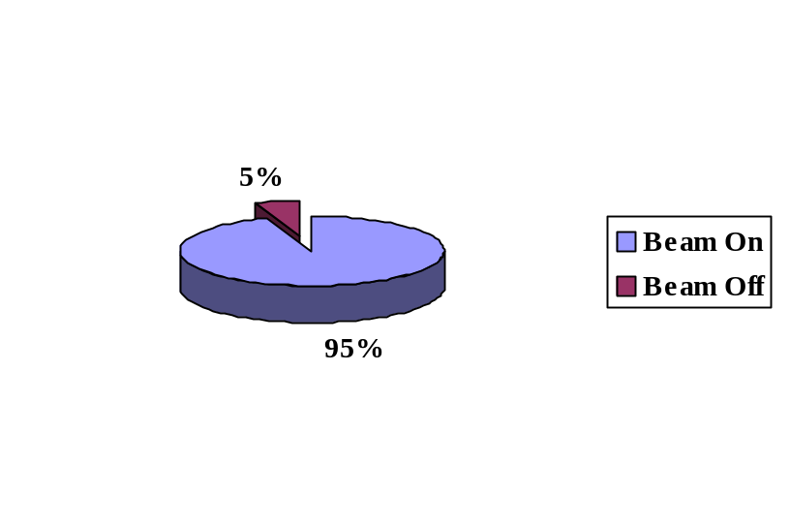Descriptive statistics

- p 1 geV/n Beam Availability

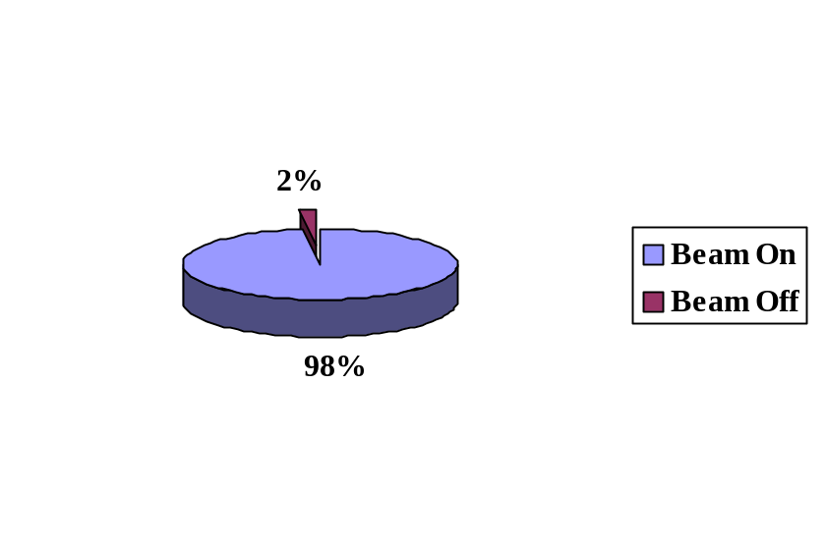
- fe 1 geV/n Beam Availability

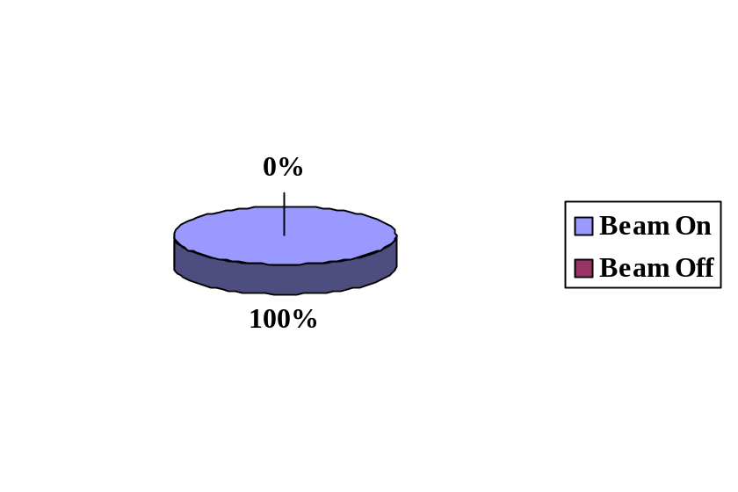

• fe 0.6 geV/n Beam Availability

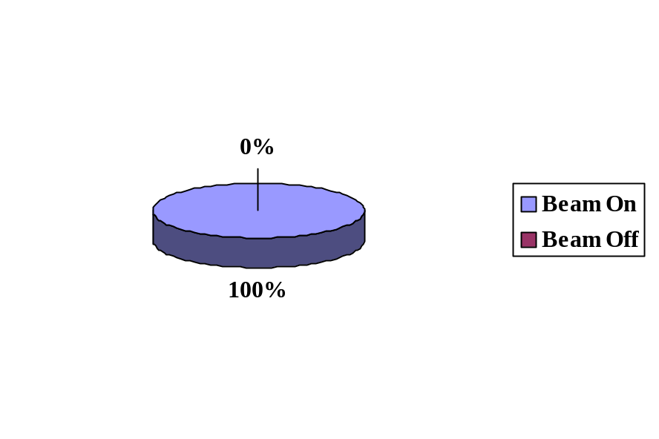• fe+p 1 geV/n Beam Availability

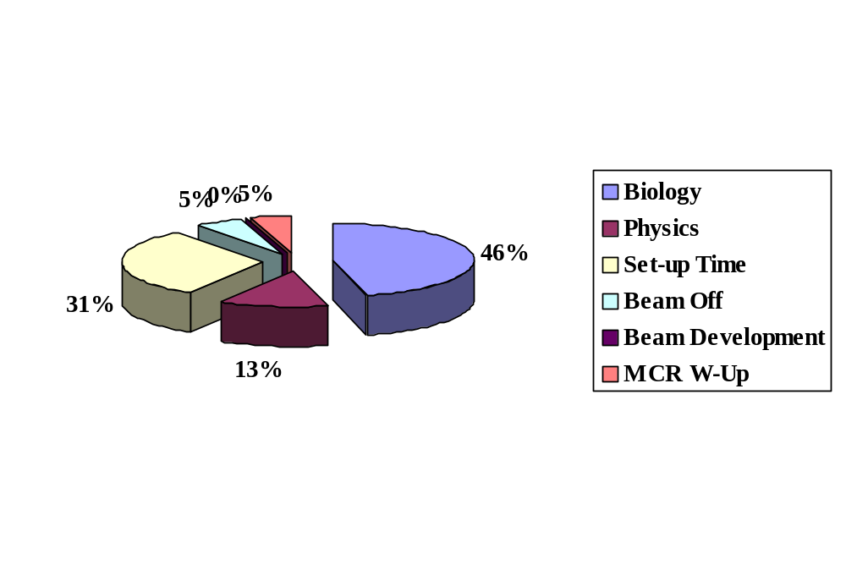PROTON RUN:
- p 1 geV/n Distribution of Beam Time Usage:

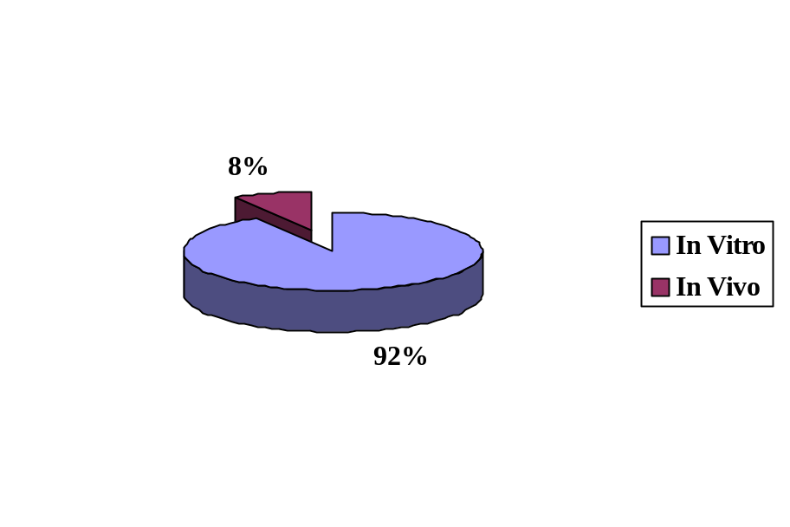

- p 1 geV/n Distribution of Beam Time for Biology:

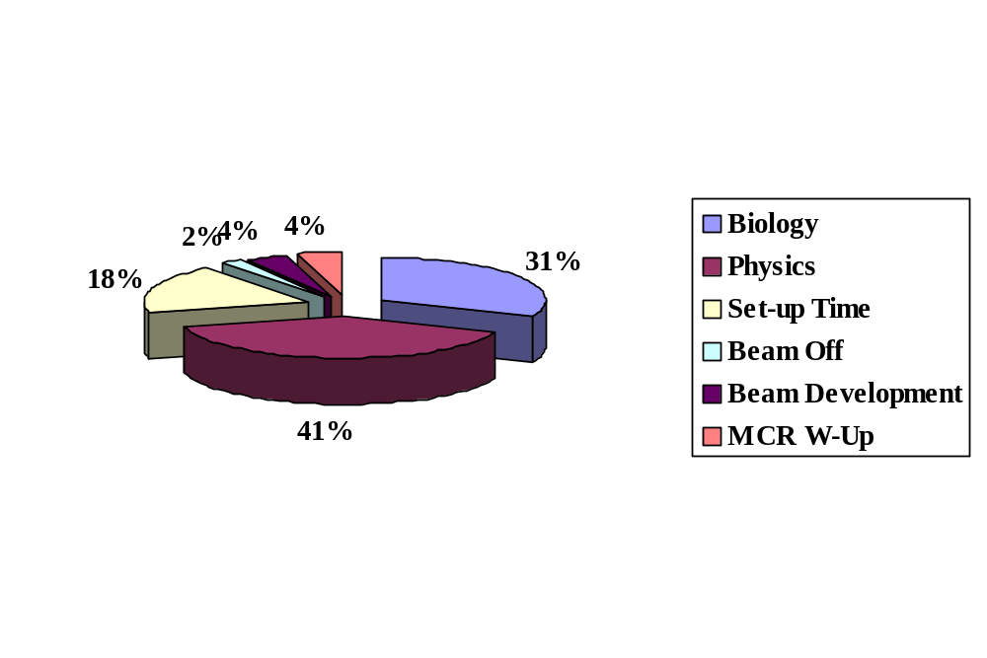

IRON ION RUN

FE 1 geV/n Distribution of Beam Time Usage:

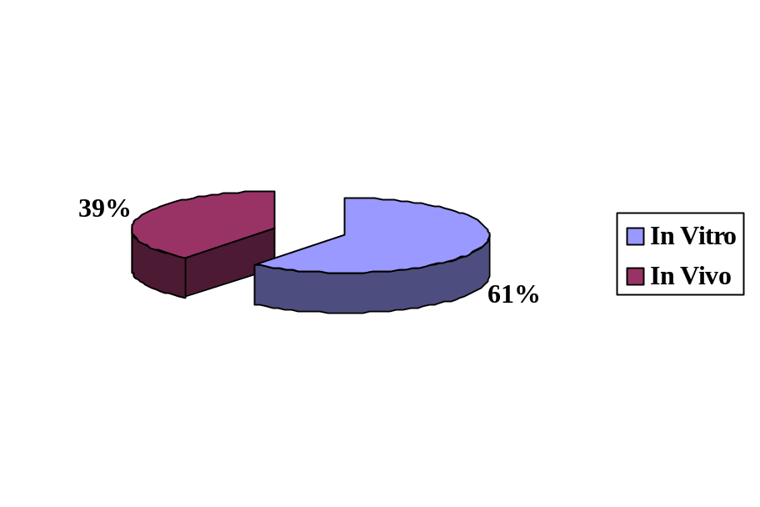

FE 1 geV/n Distribution of Beam Time FOR BIOLOGY:

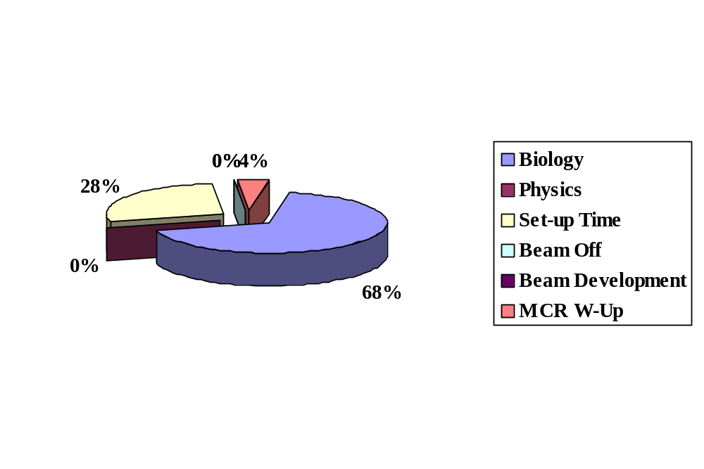

FE 0.6 geV/n Distribution of Beam Time Usage:

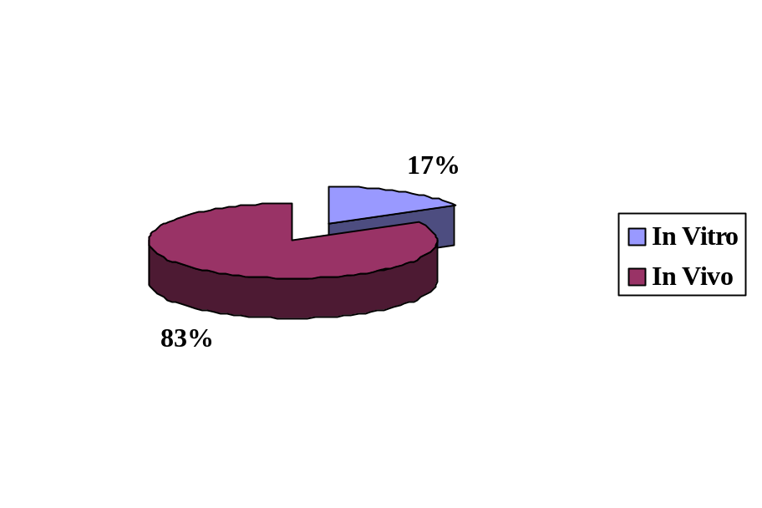

FE 0.6 geV/n Distribution of Beam Time FOR BIOLOGY:

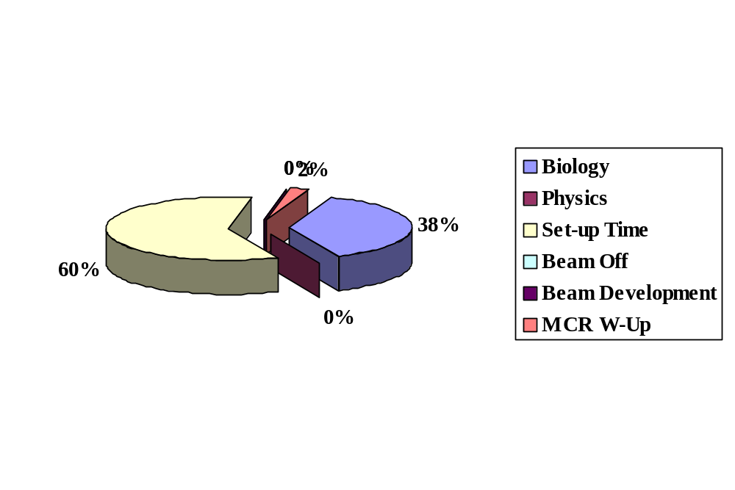

MIX FIELD RUN: IRON-PROTON RUN

FE+P 1 geV/n Distribution of Beam Time Usage:

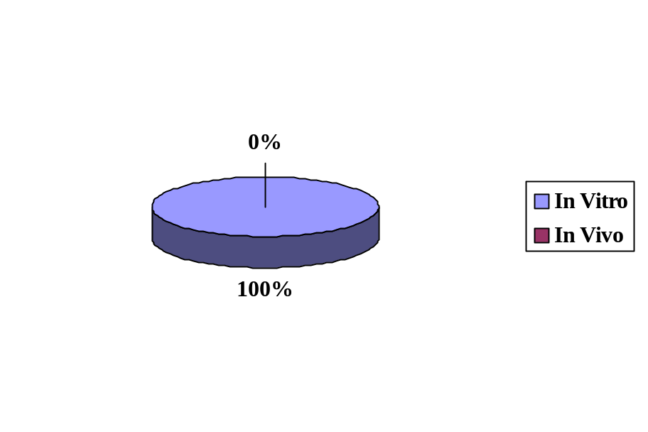

FE+P 1 geV/n Distribution of Beam Time FOR BIOLOGY:

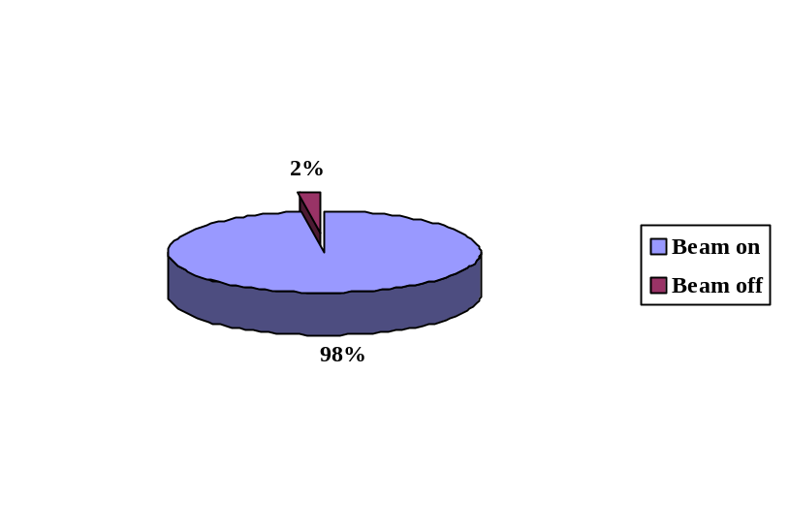NSRL-3 TOTAL BEAM TIME SUMMARY

TOTAL BEAM AVAILABILITY:

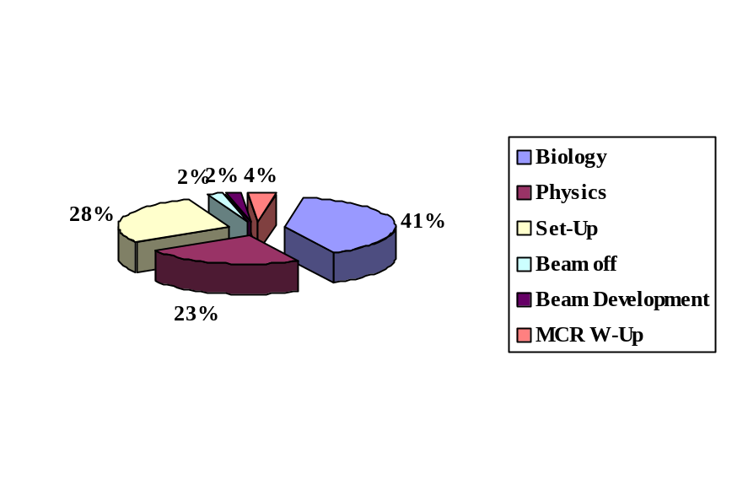

DISTRIBUTION OF BEAM TEAM USAGE:

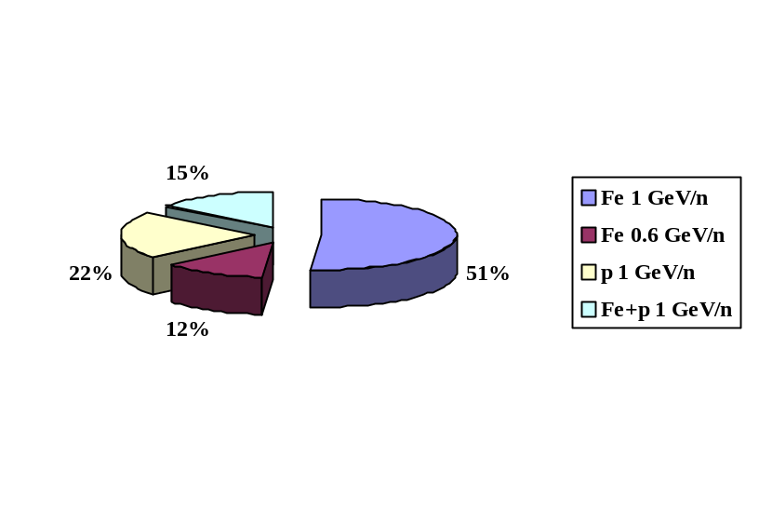

DISTRIBUTION OF BEAM TIME AVAILABLE BY SPECIES AND ENERGIES:

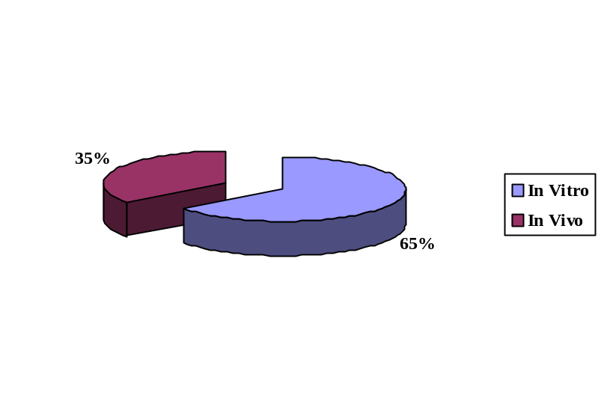

DISTRIBUTION OF BEAM TEAM FOR BIOLOGY EXPERIMENTS:

BEAM CHARACTERISTICS

Ion | ⁵⁶Fe²⁶ |  | H¹
Fluence (particles/cm²/sec)  Maximum on target  Minimum on target | TBD | TBD | TBD
Spill Period (sec) | 3.0 | 3.0 | 2.5
Spill rate (spills/min) | 20 | 20 | 24
Spill length (msec) | 400 | 400 | 400
Particles/spill  Maximum  Minimum | 1000  500 | 1.0 x 10⁹  500 | 5 X 10 ¹⁰  TBD
Beam Cut Off Accuracy | ~ 0.5 % | ~ 0.5 % | 0.5 %
Actual Energy (MeV/n)  Extracted  On Target | 600  577 | 1005  969.1 | TBD  TBD
Actual LET on Target (keV/µm) | 176.1 | 151.4 | 0.024
Max. Dose Rate (Gy/min)/  Beam Size (cm x cm)  20 x 20  10 x 10  7 x 7  7 x 30  5 x 5  1 x 1 | 0.001 | 7.0  30.0  50.0 | 0.2  1.5
Total Dose (cGy)  Maximum  Minimum | 400  15 | 400  0.1 | 2500  15

NSRL Mixed Field Test
After several hours of preparations and set-up, A. Rusek and colleagues were able to characterize the beams in order to maintain a steady and repeatable state upon switching from protons to iron. The same conditions were obtained for the iron to proton switch mode, but a more conservative approach was taken by making sure protons were established in the target area to satisfaction, and then put the sample in and exposed it to protons. We then left the sample on the target stand, switched to iron and delivered the desired dose to the sample. The longest switch time was 7 minutes. The shortest was 1 minute. The typical one was ~2 minutes. For each ion a separate setup file was used, so the calibration can change appropriately with the change of ions. So in fact, this was a mode switch of ALL systems involved, from Tandem, through transfer lines, Booster, Extraction system, NSRL line and dosimetry. Using this new tune, Dr. Sutherland was able to exposed cell samples to different combinations of proton-iron sequences in order to explore the biological effects of this mixed field. Results obtained will expand the current NSRL capabilities in order to offer a unique capability to simulate in a more realistic way the space environment.

NSRL-3 EXPERIMENTERS AND RUN STATISTICS
Exp. ID | Principal Investigator | Ion & Energy | Beam Time Approved | Beam Time Used | Dose Range (cGy) | Dose/Rate (cGy/min) | Number of Samples
B-3 | Cucinotta | Fe, 1 GeV/n  p, 1 GeV/n | 0  3.0 | 1.0  3.0 | 20-50  200-250 | 20  10-100 | 20  27
B-7 | Rabin | Fe, 1 GeV/n | 4.5 | 4.0 | 25-200 | 100 | 60
B-52 | Gewirtz | p, 1 GeV/n | 2.3 | 7.0 | NA | NA | NA
N-65 | Vazquez | P, 1 GeV/n  Fe, 1 GeV/n  Fe, 0.6 GeV/n | 4.3  6.5  4.5 | 3.0  1.5  1.5 | 15-200  “  “ | 60-100  “  “ | 30  40  50
N-66 | Narici | Fe, 0.6 GeV/n | 16.0 | 18.0 | NA | NA | NA
B-73 | Sutherland | p, 1 GeV/n | 4.5 | 7.0 | NA | NA | NA
B-88 | Sutherland | p, 1 GeV/n | 2.5 | 7.0 | NA | NA | NA
N-89 | Held | Fe, 1 GeV/n  p, 1 GeV/n | 6.0  4.5 | 5.5  7.5 | 500 to  5000 part. | 50  50 | 80  80
N-91 | Rydberg | Fe, 1 GeV/n  Fe, 0.6 GeV/n | 6  2 | 2.5  1.0 | 25-150  25-150 | 100  100 | 8  8
N-95 | Story | Fe, 1 GeV/n | 2.5 | 6.5 | 25-200 | 120-280 | 37
N-99 | Zhao | Fe, 1 GeV/n | 1.5 | 1.0 | 30-100 | 200 | 14
N-103 | Barcellos-Hoff | Fe, 1 GeV/n | 12 | 5.5 | 23-300 | 100 | 61
N-104 | Weil/Ullrich | Fe, 1 GeV/n | 7.5 | 4.0 | 10-100 | 5-50 | 41
N-108 | Pecaut | Fe, 0.6 GeV/n | 3.0 | 1.0 | 0-400 | 100-200 | 18
N-113 | Pecaut | Fe, 0.6 GeV/n | 3 | 1.0 | 0.5-400 | 0.5 - 150 | 45
N-118 | Miller | P, 1 GeV/n  Fe, 1 GeV/n  Fe, 0.6 GeV/n | 8.0  8.0  12.0 | 8.0  16.0  0.0 | NA | NA | NA
N-121 | Moyers | Fe, 1 GeV/n | 28.0 | 23.0 | NA | NA | NA
N-122 | Nelson | P, 1 GeV/n  Fe, 0.6 GeV/n | 2.5  3.5 | 2.5  0.0 | 100-2500 | 47 | 7
N-123 | Radeka | Fe, 1 GeV/n | 17.5 | 15.0 | NA | NA | NA
N-124 | Li | Fe, 1 GeV/n | 3.5 | 1.5 | NA | NA | NA
N-126 | Kennedy | Fe, 1 GeV/n  p, 1 GeV/n | 5.0  7.0 | 6.5  6.5 | NA | NA | NA
N-128 | Vazquez | Fe, 1 GeV/n | 12.0 | 13.5 | 30 -400 | 30 150 | 200
Totals |  |  | 203.1 | 180.5 | 0.5-2500 | 0.5-280 | ~826

NSRL-3 PARTICIPANTS, EXPERIMENTAL SAMPLES AND ENDPOINTS

Exp. | Participants | Samples | Endpoints
B-3 | Heavy Ion Induced Chromosome Damage and Biomedical Countermeasures  F. Cucinotta (PI) | Human Lymphocytes, Human Fibroblasts, and Chinese Hamster cells | Chromosome damage, structure effects on DNA double strand break induction and repair.
B-7 | Effects of Exposure to Heavy Particles  B. Rabin (PI) | Sprague Dawley Rats | Behavioral paradigms and neurchemistry
B-52 | Effect of Deep Space radiation on Human Hematopoietic Stem Cells.  A. Gewirtz (PI) | Human bone marrow cells | DNA complex damages, DNA replication and apoptosis, gene expression
N-64 | Risk Assessment and Chemoprevention of HZE-Induced CNS Damage.  M. Vazquez (PI) | NT2 human neural stem cells, oligodendrocytes | Survival, apoptosis, gene expression.
B-66 | ALTEA – MICE: Effects of transient heavy ion radiation on the electrophysiology of the mice visual system  L. Narici (PI) | C57Bl/6 mice and active detectors | CNS damage, electrophysiological changes in the mice visual system .
B-73 | DNA damage clusters in low level radiation responses of human cells.  B. Sutherland (PI) | T7 DNA, Human monocytes  Supercoiled DNA | DNA damage cluster induction and repair at the molecular and cellular levels
N-88 | Complex Space Radiation-induced DNA damage Clusters in Human Cell Transformation: Mechanisms, relationships and Mitigation.  B. Sutherland (PI) | Human normal fibroblasts | DNA damage cluster and transformation
N-89 | Induction of Bystander Effects by High LET Radiation in Cells  K. Held (PI) | Human keratinocytes and fibroblasts | Micronuclei formation, expression of p21 and foci formation of γH2AX
N-91 | Repair of HZE-induced DNA Double Strand Breaks and PCC Breaks.  B. Rydberg (PI) | HeLa cells, CHO cells and xrs6 cells | DSB determination, PCC and bystander effects
N-95 | Gene Expression Profile Analysis.  M. Story (PI) | Human fibroblast cell lines | Gene expression by microarray studies
N-99 | Transformation of hTERT-immortalized human  bronchial epithelial cells by  high energy heavy ions  C. Zhao (PI) | hTERT-immortalized human bronchial epithelial cells.  Mouse embryonic fibroblast (MEF) cells. | The clonal cells in soft agar will be expanded and inoculated into nude mice. The transformed cells at each stage of neoplastic process will be characterized.  Colony formation.
N-103 | Mechanism of HZE Damage and Repair in Human Epithelial Cells  M. Barcellow-Hoff (PI) | 2D and 3D HMEC cultures. | 1. DSBs induction and rejoining;  2. gene expression and  3. survival.
N-104 | Radiation Leukemogenesis  M. Weil/R. Ullrich (PI’s) | CBA/CaJ strain mice | Determination of RBE for the induction of AML using slope constants.
Exp. | Participants | Samples | Endpoints
N-113 | The Effects of Charged Particle Radiation on the CNS Response to an Immunological Stressor.  M. Pecaut (PI) | C57BL/6 | Histological Analysis of the hippocampus
N-118 | Intercomparison of Space Radiation Detectors  J. Miller (PI) | Wide variety of passive and active detectors | Ground-based intercomparison of various radiation instruments and detectors that are being used to measure the radiation exposure of crews aboard the International Space Station (ISS) and the Space Shuttle
N-121 | HZE Upgrade and Verification of 3-D Transport Code  M. Moyers (PI) | measure the charge produced in an air-filled ionization chamber as a function of depth within a water-filled phantom along the central axis of an ion beam | The first set of experiments will test the calculation of ion stopping powers for a material, energy deposition in the material, and production of large range secondary particles. The second set of experiments will test the calculation of the angular scattering power for a material and the angular distribution of long range secondary particles
N-122 | Gene Expression in the Nematode C. Elegans Following Irradiation with Charged Particles.  G. Nelson (PI) | Nematode C. elegans | Gene expression by microarray studies
N-123 | Submicron Resolution Detector Studies  V. Radeka (PI) | Silicon active particle detector and CR39 passive plastic detector | Detector position resolution and linearity measurements.  Correlation of a plastic detector and the silicon detector.
N-124 | HZE particle induced genetic instability/ oncogenic transformation and their prevention  C. Li (PI) | 10T1/2, mouse embryonic fibroblast cell lines, CADKO cell line, a mouse embryonic fibroblast with deficiency in apoptosis | Strand-breaks as indicated by immunohistochemistry staining of the phosphorylated H2AX protein.  Chromosomal aberrations  Frequency of mutations at the drug-selectable HPRT locus.
N-126 | Effects of L-Selenomethionine and other Agents on HZE Particle Radiation Induced Cell Killing and Malignant Transformation in vitro.  A. Kennedy (PI) | Htori-3 cells (Human Thyroid Epithelial Cells) | Radioprotective effects of L-selenomethionine (SeM), immunofluorescence assays, colony formation
N-128 | NASA Space Radiation Summer School  M. Vazquez | NT2 and TK6 cells, C57Bl/6 mice, films and plastic particle detectors | Cell survival, apoptosis, DNA damage, micronuclei formation, hematological changes, track structure studies.

List of personnel that participated in the planning, organization and execution of NSRL-3 run
BNL Management:
- Laboratory Director: Praveen Chaudhari
- Associate Director for High Energy and Nuclear Physics: Tom Kirk
- Associate Laboratory Director for Life Sciences: Helene Benveniste
NASA Management:
- Headquarters: Walter Schimmerling, David Tomko
- JSC: Frank Cucinotta, Frank Sulzman, Barbara Corbin
Scientific Advisory Committee:
- Betsy Sutherland (Chair), BNL
- Louis Pena, BNL
- Richard Setlow, BNL
- Kathy Held, MIT
- Les Braby, PNL
- Charles Geard, Columbia University
Collider Accelerator Department-AGS
- Chairman: Derek Lowenstein
- Deputy Chairman: W.T. Weng
- Associate Chair of Operations: A.J. McNerney
- Experimental Planning and Support Head: Philip Pile
- Associate Chair for ESHQ: Ed Lessard
- ESHQ Division Head: Ray Karol
- ESH Coordinator: Asher Etkin
- Facility Support Representative: Chuck Schaefer / Henry Kahnhauser
- Environmental Coordinator: Joel Scott
- Training and Procedures Manager : John Maraviglia
- Main Control Room: Peter Ingrassia
- Work Control Manager: Peter Cirnigliaro
- BNL Laser Safety Officer: Chris Weilandics
- Experimental Safety Review Committee: Yousef Makdisi (Chair)
- Radiation Safety Committee: Dana Beavis (Chair)
- Accelerator Safety Review Committee: Woody Glenn (Chair)
- ALARA Committee: Chuck Schaefer (Chair
- Associate Chair for ES&H/Q.A: E. Lessard
- Accelerator Division Head: Thomas Roser
- Chief Electrical Engineer: J. Sandberg
- Chief Mechanical Engineer: J. Tuozzolo
- Accelerator Physicist lead by: Leif Aherns
- Tanden Group leader: Peter Thieberger
- Physics Support: Yusef Makadisi
- CAD Components and instrumentation support: David Gassner
- AGS Radiation Safety Committee: Ken Reece
- C-A Dept Training Manager: John Maraviglia
- AGS Control Section lead by: Don Barton
- Liaison Engineering Group lead by: David Phillips
- Liaison physicist: Adam Rusek
- RHIC&AGS Users Center: Susan White-DePace, Angela Melocoton
- Mechanical Service Technicians led by: Fred Kobasiuk
- Survey Group led by: Frank Karl
- Beam Service Technicians led by: Paul Valli
- Electronic Service Technicians led by: Bill Anderson
- AGS Instrumentation Group led by: Pete Stillman
- AGS Main Control Room and Operations led by: Pete Ingrassia
- AGS MCR Operation Coordinators:
Jim Jamilkowski
Greg Marr
Sanjee Abeytunge
Jennifer Kozak
Brian van Kuik,
Travis Shrey
- AGS Electricians led by Bill Softye
- AGS Riggers led by: Nick Cipolla
- Carpenter and Welder Support Service and Technical Support led by: Roger Hubbard
Dosimetry:
- Don Lazarus
- Adam Rusek
- I-Hung Chiang
- Kin Yip
- Peter Oddo
- Bart Frank

Medical Department:
NASA LTSF TEAM:
- Medical Liaisons: Marcelo E. Vazquez, Peter Guida
- Technical support: Bea Pyatt, Stacey Russell, Adele Billups
- Dept. Chair: Helene Benveniste
- Building Manager: Chris Harris
- Administration: Denise White and Donna Russo
- Animal Care Facilities: Maryann Kershaw, Kerry Bonti, Patricia Leone
- Training Coordinator: Ann Emrick
- RCD
- Kay Conkling
- Dennis Ryan
- Deana Buckallew
- Jim Williams
- Bob Colichio

Plant Engineering:
- BLAF Custodian, P. Abrams
- Plumbers: B. McCafferty
- Painters/Carpenters: B. Laakmann
- Electricians: T. Baldwin
Biology Department:
- Chairman: Carl Anderson
- Biology Liason: Betsy Sutherland
- Technical Support: Mamta Naidu, Debasish Roy
- Cesiun Source Manager: Richard Sautkulis

